Instructions for WiFi Intelligent Double-path watering device

This manual only applies to WD-01ADE.
Please read the instructions carefully before using the product.
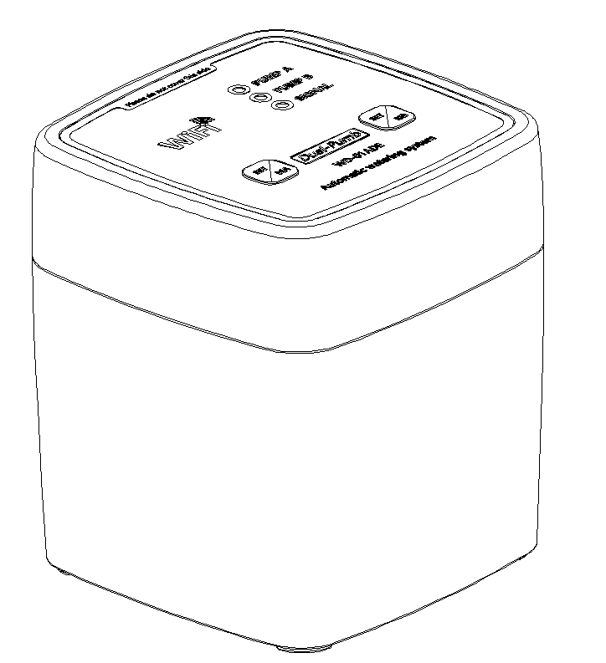






Product introduction 用本公司生产的WD-
Thank you for choosing the WiFi dual-way automatic flower sprayer produced by our company. This product has a novel appearance, suitable for home, office and other scenarios; Selected high quality ABS+PP raw materials, anti-brittle cracking oxidation performance is good. The product is developed based on the Internet of Things platform. It is connected to WiFi and can be controlled remotely after setting through mobile APP. You can set the watering time and frequency in the APP according to your needs. The chip has built-in clock function, and the flower sprayer will also work on time according to your setting when offline.
This product is equipped with domestic famous brand miniature diaphragm pump, with high efficiency, low noise, small vibration, high suction, high head, long life and many other advantages. 4 AA batteries and adapter dual-mode uninterrupted power supply, high quality WIFI module with SMT process control module, safe and reliable, let you easily, carefree.

Function introduction
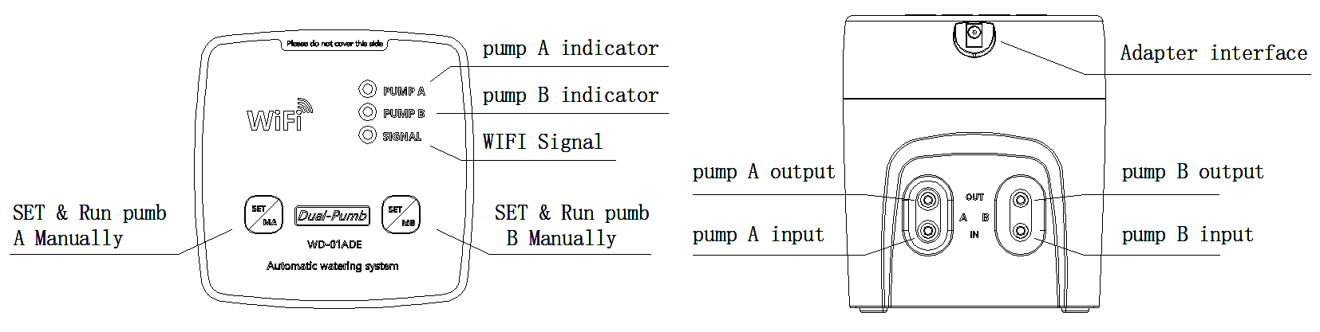
When you click Set / MA, pump a will run manually; when you click Set / MB, pump B will run manually; long press the key for 5 seconds to switch the matching mode.

Product parameters
Rated voltage：5 V Size ：83*83*95（L*W*H) Lift ：≥2.5 m
Rated current：720 mA net weight： 240g Suction：≥2m
Power：3.6 W Body material: >ABS< Wifi: 2.4GHz
Connection caliber：∅4.8 mm Water pipe：4/6 ,4/7
Maximum pressure:≥30psi(200kpa) Battery model： 4-AA 1.5v
Water flow：0.3-0.8 LPM Adapter：DC 5V 2A DC002 3.5/1.3
Noise range：≤65 db(30cm） Ambient temperature：0℃-50 ℃

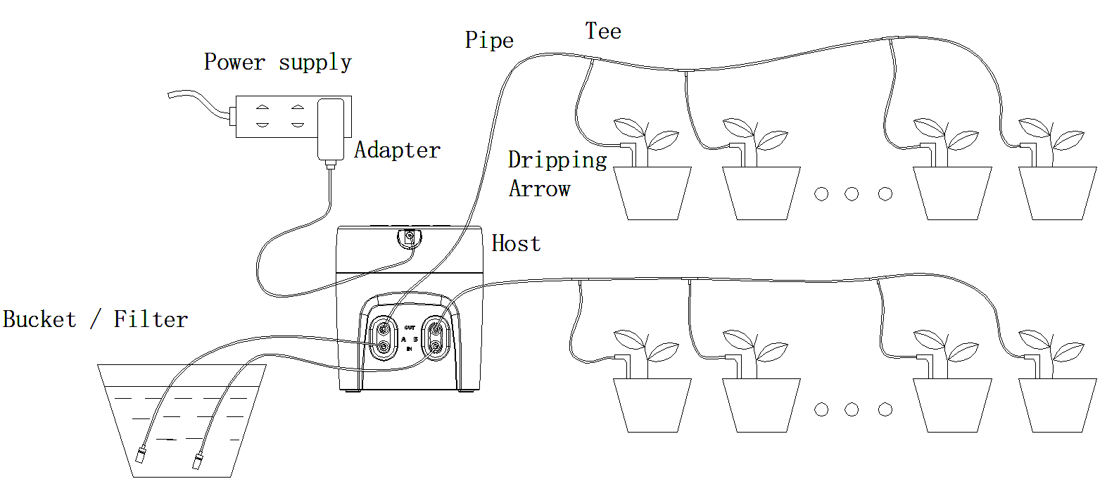
Connection method

Operation process
Download app ▶ registration&login ▶ connection device ▶ setting parameters
Download app
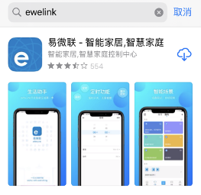
Search "ewelink" by mobile phone, download and install the app.

registration&login
Users in the mainland of China can register with their mobile phone numbers, while users in other regions can register and log in by email. If you have already registered an e-micro account, you can enter your account to log in.
connection device
Power on the watering device and keep it in the same WiFi signal with the mobile phone, and ensure that the WiFi is 2.4GHz. At this time, the blue signal indicator lights up, and different flashing modes represent different states, as follows:
2short and 1 long: pairing mode continuous flash: compatible pairing mode slow flash: offline / unconnected normally on: Networking
When the unpaired device is powered on, it is in pairing mode by default (2 short and 1 long). Long press any setting button for 5 seconds to switch to compatible pairing mode (continuous flash); when offline (slow flash), long press any setting button for 5 seconds to enter pairing mode (2 short and 1 long).
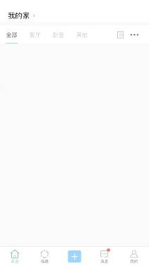

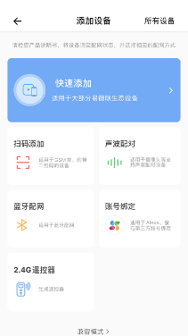

Select add a device

Choose quick add
Enter app, click + to add device.

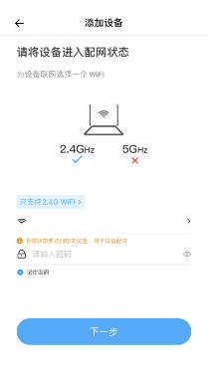
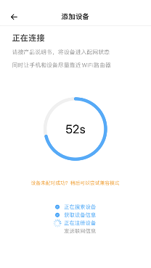
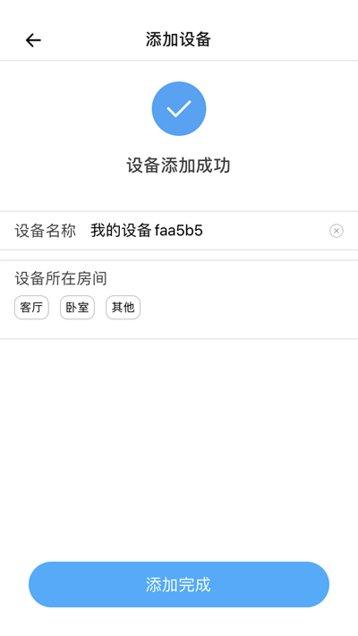
Select the WiFi you want to connect to and enter the password
Make sure the device is in pairing mode (2 short and 1 long)

Device addition complete

Please note that
1.The mobile phone and flower watering device should be close to the router as far as possible to obtain stronger WiFi signal; WiFi must be 2.4GHz.
2. During pairing, please make sure that the device is in pairing mode (signal light status is 2 short and 1 long). If it is not in pairing mode, you can press any key for 5 seconds to switch modes.
3. In case of pairing failure, please check the software permission settings to ensure that the app has WiFi and location access rights.
4. Pairing always fails. Please try compatible pairing mode.
compatible pairing mode
When pairing mode fails to connect normally, you can select compatibility mode to connect. When connecting, please adjust the matching mode of flower watering device to "compatible matching mode", and the signal indicator light is continuous flash. At this time, according to the hot spot name and password prompted by the mobile phone, select to connect to the hot spot. In the pop-up dialog box, allow ewelink to join WLAN.
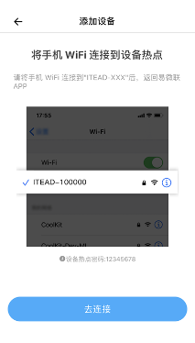
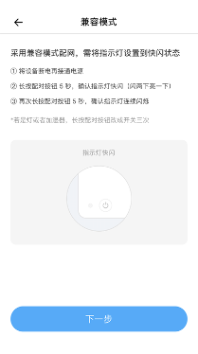
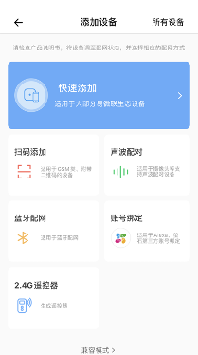

Hotspot name and password

Click compatibility mode

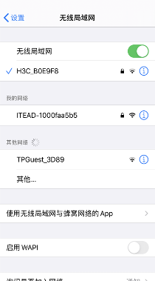
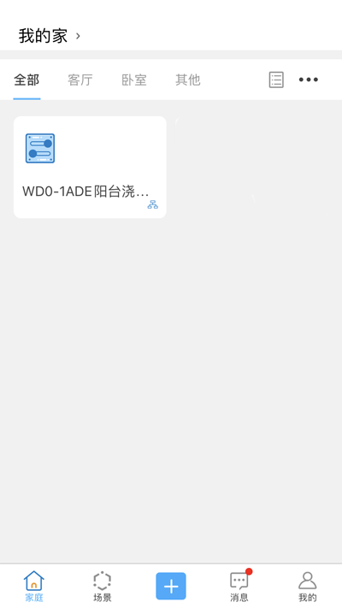
Select this device hotspot

After adding, click here to modify the device name
Device addition complete

setting parameters
After adding the device, click to enter the device to set the working time and frequency of the flower watering device according to your needs.
Watering working time setting: enter the equipment interface --- click option setting (three points in the upper right corner) -- inching setting. Turn on the inching state of channel 1 and channel 2, and set the watering time you need (channel 1 is pump a, channel 2 is pump B). After setting, please click the top right corner to save. Under the manual or automatic state, the water pump will run according to the inching time you set, and stop after reaching the set time.
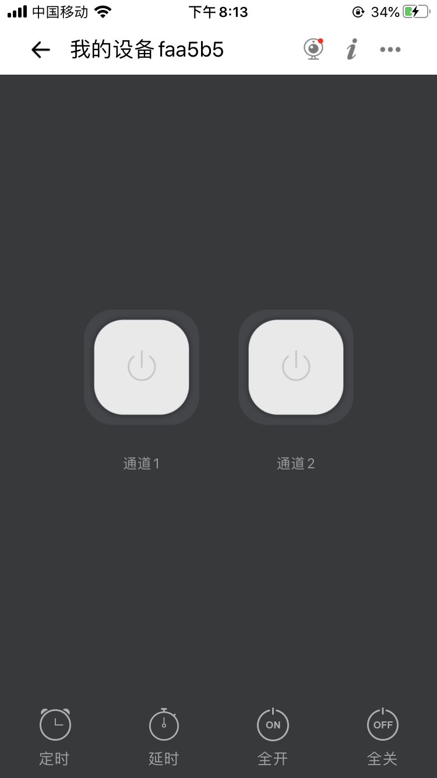
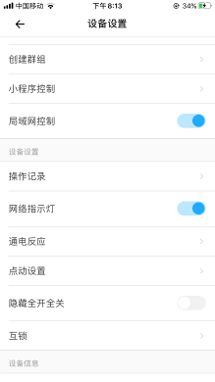
Click options

Click to enter the device interface
inching setting

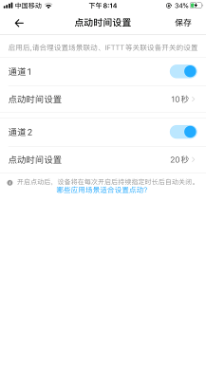
Pumb A working time

Pumb B working time

Timing scheme setting
click the timing icon --- add a new timing scheme --- select time, date and channel (action mode is open) -- please click save after setting.
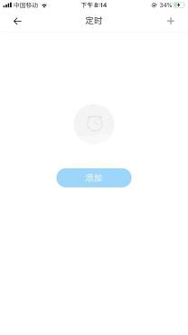
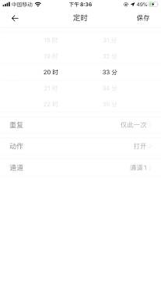

Click timing

Please note that
1. Channel 1 corresponds to pump a; channel 2 corresponds to pump B. the starting time of the two pumps is set separately, and the user can set multiple groups of watering schemes.
2. After setting, whether the device is online or offline, the built-in chip will execute the setting procedure on time according to the setting.
matters needing attention
1. Large capacity and small caliber containers (such as pure water bucket) should be selected as far as possible to meet the capacity demand and reduce water evaporation;
2. The position of the water container is relatively lower than the flowerpot to prevent the water in the bucket from directly flowing into the flowerpot without starting up in the sealed pipeline.
3. When it is difficult to plug in and out the pipeline, hot water can be used to soften it before plugging in and out.
4. Correctly use the inlet pipe filter, and do not use the sewage with large particle impurities as the water source to prevent blocking the water pipe or pump.
5. Before setting the watering time, test the water flow and time manually.
6. The host has built-in circuit control board. Please do not place it in the open air. Rain, soaking and other harsh environment will cause fatal damage to the host.
7. When not in use for a long time, pull out the adapter, take out the battery, and properly place the host in a dry environment.
8. Under the condition of only using battery power supply, the endurance depends on the working frequency, working intensity, battery performance and other comprehensive conditions. When replacing batteries, 4 batteries need to be replaced at the same time.
9. The automatic watering device is only used for intermittent watering, and can not be used as a pump to continuously transport fluid medium for a long time, otherwise it will seriously reduce the service life of the main engine diaphragm pump.

